August 2024 Our ref: LG/DL/lm

Dear GCSE Student,

GCSE EXAMINATION RESULTS

It must seem like a long time since you took the examinations – but here, at last, are your GCSE results! I hope that you are pleased with your achievements, but if you have any concerns, please discuss them with Mr Hibberd, Mrs Fanous, Mrs Lewis, or myself.

There are some important administrative points that you need to be aware of at this stage:

- If you are unhappy with your grade, especially if it is close to a higher-grade boundary, you can ask for a paper to be reviewed. You should note that if you ask to have the mark of any of your papers reviewed, the grade that you have obtained might be revised to a higher but also a lower grade than the one that you have now. To request a review, please read the information sheet enclosed in this envelope which outlines costs, deadline dates and has the link to the post exam services request form. You will need pay in the school finance office by card or over the phone on 01392 355990 for post exam services when you request them.

- You have the option of asking to see your written scripts. This may be purely for your own interest, or in connection with a possible enquiry of results. It is often useful for your subject teachers to look over your scripts to see if a review of results is a viable option, before requesting this service. If you wish to have any scripts returned, you should complete the ‘Access to scripts’ electronic form, found on the information sheet. Again, we shall need you to pay for this service when you make the request.

- Teachers may like to use your scripts to help them prepare candidates for future examinations. If you agree with the staff using your script, please complete the form to request access to scripts, putting N/A in the subject sections.
- Exam certificates arrive in school during October/November. You must arrange to collect your certificates in person from the school from November 2024 onwards. Please inform Mrs Lewis (Donnalewis@maynard.co.uk) prior to collection, so that they can be left in Reception. If you cannot collect them personally, you will need to give written consent for a third party to collect on your behalf. Certificates can only be retained within school for one year, so please try to collect them as soon as you can.

Yours sincerely
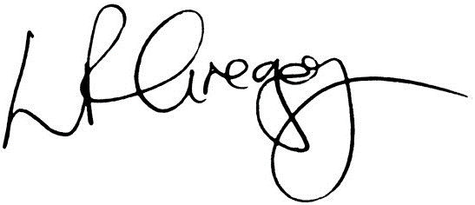
Mrs Gregory
Head

